ONLINE QUIZ SYSTEM
Software Engineering Mini Project | Team 14

Deliverable 1
Software Requirements Specification • Test Plan • Software Architecture and Design Specification
Document control | Value
Version | 1.0 | 28 September 2026
Project type | Console based multiple choice quiz system
Implementation baseline | C++17, single machine, local persistent storage
Status | Proposed specification for implementation and validation

This document defines the intended behavior of Team 14’s Online Quiz System, the tests that will verify it, and the design that will guide implementation. The project assignment describes a console based multiple choice game with questions and scoring in C or C++. The concrete C++17 design choices below form a consistent baseline for review; the team can revise them through version control before implementation.

Contents
- Part A Software Requirements Specification
- Part B Software Test Plan
- Part C Software Architecture and Design Specification
Requirement identifiers are stable across the three parts. A test case refers to the exact requirement it checks, and architecture components list the requirements they realize.

Part A Software Requirements Specification

1 Introduction

1.1 Purpose
Specify a local console application in which an administrator maintains multiple choice questions and quizzes, learners take quizzes, and the system calculates and stores results. The primary audience is the development team, reviewer, and test team.

1.2 Scope
The first release supports one user interacting with the console at a time. It stores named users, question banks, quiz definitions, attempts, and scores on the same machine. Internet play, payments, proctoring, multimedia questions, live multiplayer, and synchronization across devices are out of scope.

1.3 Terms
Term | Meaning
Learner | Registered user who can take quizzes and inspect own results.
Administrator | Authorized user who can manage questions, configure quizzes, and view summary results.
Question | Prompt with four choices and exactly one correct answer.
Attempt | One submitted or in progress quiz run belonging to one learner.

2 Overall description
The system has a menu driven console interface, a controller for input and role checks, services for authentication and quiz logic, and a repository adapter for local files. A quiz references an ordered set of active question IDs. The administrator prepares quiz content; the learner signs in, selects a quiz, answers each question, submits, and sees a score.

2.1 Users and operating environment
- Learners use a keyboard and terminal capable of displaying UTF 8 text.
- Administrators work at the same console but see management commands after authentication.
- Target environment: a C++17 compiler and a writable local data directory. No network service or browser is required.

2.2 Assumptions and constraints
- Each question has four text choices and exactly one correct choice, identified internally as A through D.
- An attempt is scored once on submission; each correct answer earns one point and there is no negative marking.
- The application must preserve data across a normal restart. Local storage is not a defense against an operating system administrator with direct file access.

3 External interface requirements
The console shall show a numbered menu with instructions for every prompt, report invalid entries without terminating, and display quiz scores as both correct count and percentage. Files used for persistence are internal implementation details and shall not be edited by learners through the application.

4 Functional requirements

FR-01 Registration
The system shall create a learner account when a unique nonempty username and a password of at least 8 characters are provided; duplicate usernames shall be rejected.

FR-02 Sign in
The system shall authenticate a registered username and password before displaying learner or administrator actions; an invalid pair shall show a generic failure message.

FR-03 Question maintenance
An authenticated administrator shall create, edit, or deactivate a question only when its prompt and four choices are nonempty and exactly one correct choice is selected.

FR-04 Quiz configuration
An authenticated administrator shall create or edit a quiz with a nonempty title and at least one active question; a quiz may not reference an unknown question.

FR-05 Quiz discovery
An authenticated learner shall see available quizzes with a title and question count and may select one by its displayed identifier.

FR-06 Attempt flow
For a selected quiz the system shall present each configured question exactly once, with choices A through D, and record one selected choice per question.

FR-07 Input recovery
When an answer is not A, B, C, or D, the system shall show an error and re-prompt the same question without recording the invalid input.

FR-08 Scoring
On submission the system shall calculate correctCount as the count of stored answers matching the answer key and percentage as 100 × correctCount / totalQuestions, rounded to one decimal place.

FR-09 Own results
A learner shall see only their own completed attempts with quiz title, date, correct count, total count, and percentage.

FR-10 Admin summary
An administrator shall see completed attempts with username, quiz title, date, and score; an ordinary learner shall not be able to invoke this operation.

FR-11 Persistence
The system shall save account, quiz, question, and completed attempt records before confirming successful create, edit, or submission operations, and reload them after restart.

5 Nonfunctional requirements

NFR-01 Responsiveness
With at most 1,000 stored questions and 10,000 attempts on the reference machine, a menu transition or question load shall complete within 2 seconds for 95% of local interactions, excluding time waiting for user input.

NFR-02 Recovery
If a file write fails, the operation shall report failure and leave the last committed data file readable; updates shall use a temporary file and atomic replacement where the operating system supports it.

NFR-03 Usability
Every menu and question prompt shall show accepted input values; an invalid choice shall produce a specific correction prompt without an application crash.

NFR-04 Portability
The source shall compile as C++17 on a supported Windows or Linux build with a documented build command; platform specific file handling shall be isolated in the repository adapter.

6 Security objectives and requirements
Objectives: SO-01 restrict question and quiz changes and aggregate result access to administrators; SO-02 protect stored credentials and avoid exposing a learner’s results to another learner; SO-03 preserve valid saved state when input or storage operations fail.

SEC-01 Password protection
The system shall use a vetted password hashing library with a unique random salt per account and an adaptive hash algorithm such as Argon2id; it shall never persist plaintext passwords.

SEC-02 Role checks
The controller shall check the authenticated role on every administrator operation, including direct internal calls, and shall deny a learner account.

SEC-03 Result ownership
The result service shall compare the authenticated learner ID with the owner ID on every own history request; it shall not accept an arbitrary owner ID from console input.

SEC-04 File validation
On loading local data, the repository shall reject malformed records and report a recoverable error rather than interpreting them as privileged accounts or valid scores.

7 Use case model
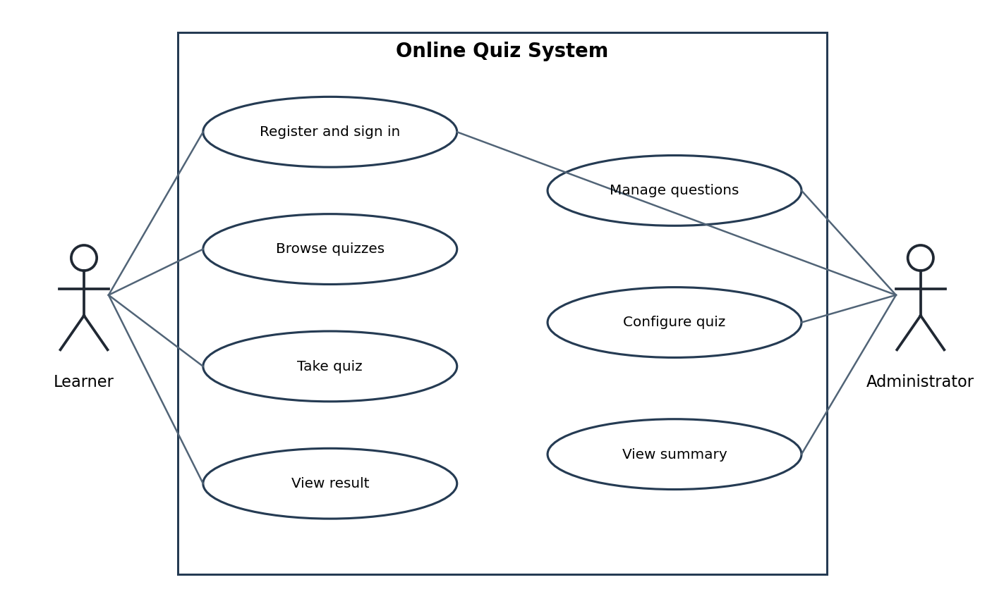
Figure 1 UML use case diagram for learner and administrator
Main success path for Take quiz: sign in, browse a quiz, select it, answer each question, submit, and view the result. Alternate path: invalid answer repeats the current prompt. Precondition: an administrator has configured at least one available quiz.

8 Requirements acceptance summary
The requirements are accepted only after the test cases in Part B pass on the documented reference environment. Any implementation change that affects the behavior, score formula, storage, or security checks requires an updated requirement and test mapping.

Part B Software Test Plan

1 Introduction
This test plan defines how Team 14 will validate the console based Online Quiz System against the identifiers in Part A. The planned tests are specifications for execution after implementation; their outcomes are not claimed as passed in this document.

2 Scope and test items
Test items are the console executable, authentication service, question and quiz management, attempt/scoring logic, result access, and local repository. Tests use a disposable directory and known sample data. Network and browser behavior are outside scope.

3 Features to be tested
Area | Requirements | Verification
Accounts and access | FR-01, FR-02, SEC-01, SEC-02 | Register, sign in, deny role escalation; inspect persisted credential representation.
Quiz authoring | FR-03, FR-04 | Validate question fields, references, and admin edits.
Quiz delivery | FR-05, FR-06, FR-07, NFR-03 | Browse, answer, and recover from invalid input.
Scores and results | FR-08, FR-09, FR-10, SEC-03 | Known answer key, ownership, and admin summary.
Persistence and quality | FR-11, NFR-01, NFR-02, NFR-04, SEC-04 | Restart, failure injection, timing, and two platform builds.

4 Features not to be tested
Online synchronization, timed proctoring, negative marking, multimedia questions, payment handling, and concurrent sessions are excluded because they are outside the release scope. The operating system’s access controls and the cryptographic library’s own implementation are not audited; the application’s use of those facilities is tested.

5 Test approach
Use black box console scenarios for observable behavior, unit tests for scoring and validation, integration tests for persistence and role checks, and manual review of rendered prompts. Reset the data directory before each independent test. Seed one administrator, two learners, one quiz with three questions, and a known answer key A, C, B. Record actual results, environment, tester, and date during execution.

5.1 Security validation
Verify that stored passwords are salted hashes, that direct admin service calls reject learner sessions, and that a learner cannot read another learner’s history. Use malformed persisted records in a disposable directory to check safe rejection. Never include actual user passwords in screenshots or test logs.

5.2 Entry and exit criteria
- Entry: build succeeds, isolated test directory exists, seed fixtures are available, and the requirement version matches this plan.
- Exit: all critical security and scoring cases pass; all planned cases are executed; remaining defects are documented with severity and a retest decision.

5.3 Environment and evidence
Record compiler and version, operating system, build command, seed files, observed console transcript, and test result. For NFR-01, collect at least 20 local transitions with 1,000 questions and 10,000 attempts on one documented machine and report the 95th percentile. For NFR-04, compile and run smoke tests on Windows and Linux.

6 Planned test cases

TC-01 Register learner
Precondition | Action | Expected result | Trace
Empty data; username alex | Register alex with a valid 8 character password, then repeat username | First succeeds; duplicate rejected; one account stored | FR-01, FR-11

TC-02 Authenticate and protect password
Precondition | Action | Expected result | Trace
Seed learner alex | Sign in with wrong then right password; inspect account file | Wrong pair denied with generic message; right pair accepted; no plaintext password stored and unique salt exists | FR-02, SEC-01

TC-03 Deny unauthorized authoring
Precondition | Action | Expected result | Trace
Learner session active | Invoke create question and create quiz operations | Both return access denied; no question or quiz change persists | FR-03, FR-04, SEC-02

TC-04 Validate authoring and configuration
Precondition | Action | Expected result | Trace
Admin session; one active question | Try empty option and unknown question reference, then create valid question and quiz | Invalid entries rejected; valid data saved and reloaded after restart | FR-03, FR-04, FR-11

TC-05 Browse and complete attempt
Precondition | Action | Expected result | Trace
Learner; 3 question quiz with key A C B | List quizzes; choose quiz; enter A C B | Quiz listed with count 3; each question displayed once; 3 answers stored | FR-05, FR-06

TC-06 Recover from bad choice
Precondition | Action | Expected result | Trace
Attempt on first question | Enter X, then A | X rejected with guidance; same question reappears; only A recorded | FR-07, NFR-03

TC-07 Score known answers
Precondition | Action | Expected result | Trace
3 question quiz with key A C B | Answer A D B and submit | 2 of 3 correct; displayed percentage 66.7%; one completed result | FR-08

TC-08 Enforce result ownership
Precondition | Action | Expected result | Trace
Two learners each with one result | As learner A request history; attempt internal access to B history | Only A records returned; B records denied | FR-09, SEC-03

TC-09 Administrator summary
Precondition | Action | Expected result | Trace
Two completed learner results | As admin open summary, then as learner attempt same operation | Admin sees both results; learner is denied | FR-10, SEC-02

TC-10 Storage failure and malformed data
Precondition | Action | Expected result | Trace
Disposable data directory | Inject write failure; restart using malformed account record | Failure reported; prior committed data readable; malformed record rejected without creating admin session | NFR-02, SEC-04

TC-11 Response time at load
Precondition | Action | Expected result | Trace
1,000 questions and 10,000 attempts | Measure at least 20 menu and question loads | 95th percentile is at most 2 seconds on the documented machine | NFR-01

TC-12 Cross platform build
Precondition | Action | Expected result | Trace
Windows and Linux C++17 toolchains | Build and execute one sign in and quiz smoke test on each | Both compile and complete smoke test using documented commands | NFR-04

7 Traceability and reporting
The trace column in each test case maps directly to Part A. Requirement coverage before execution is 11 functional, 4 nonfunctional, and 4 security requirements. Record actual status as Pass, Fail, or Blocked with defect reference and evidence location; this plan contains expected results only.

Part C Software Architecture and Design Specification

1 Introduction and design drivers
The design implements the requirements in Part A with a small modular C++17 application. Primary drivers are clear console interaction, deterministic scoring, persistent local records, and role restricted administration. The application runs as one process on one machine.

2 Architecture pattern
Use a layered architecture: console presentation calls an application controller; domain services implement authentication, quiz attempts, and result access; a repository adapter handles persistence. The domain layer must not read from standard input or write directly to files. This separation permits deterministic unit tests and alternative storage later.

3 Component diagram and responsibilities
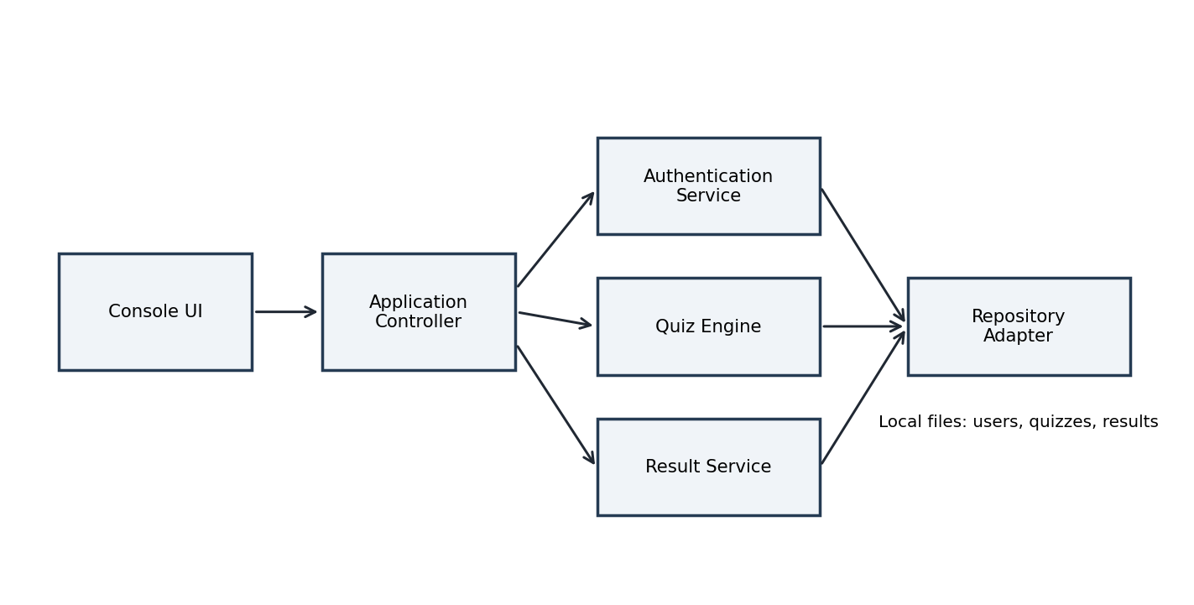
Figure 2 UML style component diagram and dependency direction
Component | Responsibility | Requirement links
Console UI | Render menus, collect and validate basic input | FR-05 to FR-07, NFR-03
Controller | Maintain session, route commands, enforce admin gates | FR-02, FR-03, FR-04, FR-10, SEC-02
Authentication Service | Verify password hash and role, issue in process session | FR-01, FR-02, SEC-01
Quiz Engine | Load questions, record choices, calculate score | FR-04 to FR-08
Result Service | Persist attempts and filter learner or admin views | FR-09, FR-10, SEC-03
Repository Adapter | Validate records and commit data safely | FR-11, NFR-02, SEC-04

4 Data design
Entity | Core fields and constraints
User | userId, unique username, passwordHash, salt, role in {Learner, Admin}; no plaintext credential field.
Question | questionId, prompt, choices[4], correctChoice in {A, B, C, D}, active flag.
Quiz | quizId, title, ordered questionIds with at least one active question.
Attempt | attemptId, userId, quizId, submittedAt, selectedChoices, correctCount, totalQuestions; score is derived.

Stable identifiers preserve references if display titles change. A submitted attempt stores an immutable snapshot of its answer evaluation so subsequent question edits do not silently change historical scores. Repository writes create a validated replacement file and then rename it over the old file; failure leaves the old file available.

5 Security architecture
Trust boundary: console input and disk records are untrusted; domain operations receive an authenticated session object. The controller denies unauthorized commands and services independently recheck permissions. The authentication service uses a vetted Argon2id library with independent random salts and never logs credentials. Result queries derive the owner from the session, not a supplied username. The repository validates schema and enum values before constructing domain objects.

6 Detailed interaction design

6.1 Learner takes a quiz
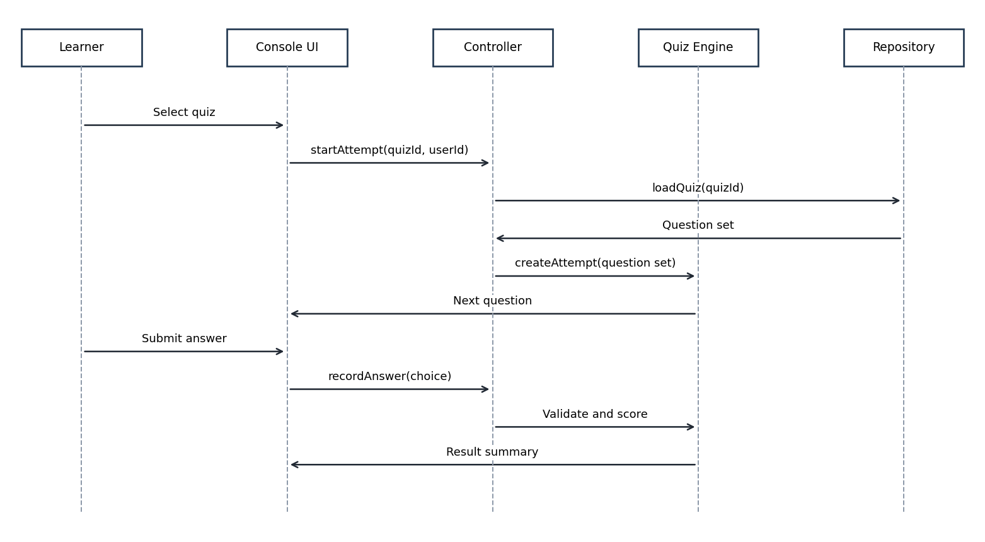
Figure 3 UML sequence diagram for quiz attempt and scoring
The quiz engine retains the selected question order for the attempt, records one valid answer for each question, and computes the result exactly once on submission. Persistence must succeed before the console reports a saved result.

6.2 Administrator maintains a question
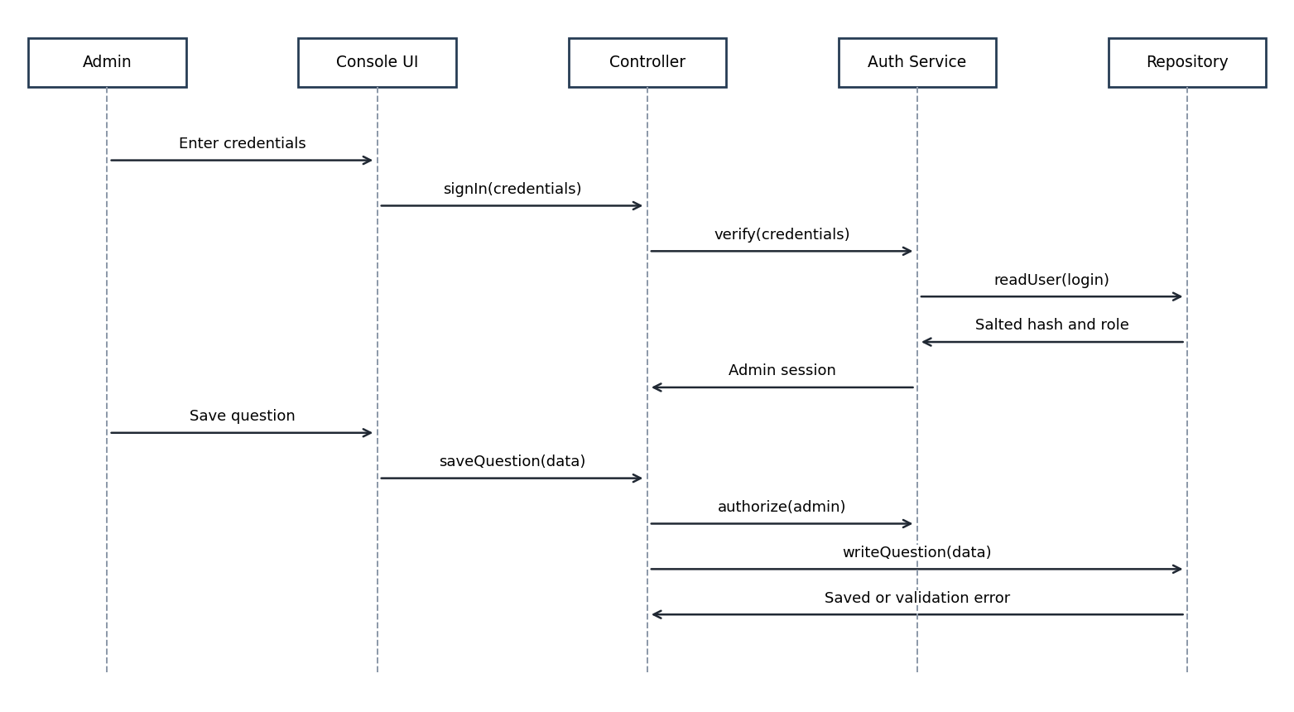
Figure 4 UML sequence diagram for authenticated question update
Both the controller and the administrative service verify authorization. Validation occurs before the repository commit; a failed commit returns an error and does not claim success.

7 Internal API design
Because this is a single process console application, these are C++ service interfaces rather than HTTP endpoints. Result<T> carries either a value or a typed error; IDs are opaque integers. Methods accept structured input rather than parsing console strings.
Operation | Input | Output and error behavior
AuthService::registerLearner | username, password | Result<UserId>; DuplicateUser, ValidationError, StorageError
AuthService::signIn | username, password | Result<Session>; AuthenticationFailed, StorageError
QuizService::saveQuestion | AdminSession, QuestionDraft | Result<QuestionId>; AccessDenied, ValidationError, StorageError
QuizService::saveQuiz | AdminSession, QuizDraft | Result<QuizId>; AccessDenied, UnknownQuestion, StorageError
QuizService::listQuizzes | LearnerSession | Result<vector<QuizSummary>>; StorageError
AttemptService::start | LearnerSession, QuizId | Result<AttemptId>; QuizUnavailable, StorageError
AttemptService::answer | LearnerSession, AttemptId, Choice | Result<NextQuestion>; InvalidChoice, AttemptClosed
AttemptService::submit | LearnerSession, AttemptId | Result<Score>; IncompleteAttempt, StorageError
ResultService::ownHistory | LearnerSession | Result<vector<Result>>; AccessDenied, StorageError
ResultService::summary | AdminSession | Result<vector<Result>>; AccessDenied, StorageError

8 Error handling and recovery
Condition | Handling
Invalid console input | Explain accepted values and re-prompt; do not mutate attempt state.
Authentication or role failure | Return generic sign in failure or access denied; do not reveal which credential was wrong.
Invalid record on disk | Reject record, report recovery action, and do not infer elevated privileges.
Write failure | Return StorageError; retain last committed file and allow retry after storage is repaired.
Missing quiz or question | Return typed error; do not dereference absent data or show a partial result.

9 Architecture traceability
Design element | Requirement coverage | Verification
Console UI and Controller | FR-01 to FR-07, FR-10, NFR-03, SEC-02 | TC-01 to TC-06, TC-09
Authentication Service | FR-01, FR-02, SEC-01 | TC-01, TC-02
Quiz Engine | FR-04 to FR-08 | TC-04 to TC-07
Result Service | FR-09, FR-10, SEC-03 | TC-08, TC-09
Repository Adapter | FR-11, NFR-02, SEC-04 | TC-01, TC-04, TC-10
Build and performance harness | NFR-01, NFR-04 | TC-11, TC-12

10 Build and deployment view
Build a C++17 executable and link a vetted Argon2id password hashing dependency. At startup, create or open a configured local data directory and load validated records. Distribute a build guide and seed administration procedure with the implementation; do not ship a hard coded default password. The first administrator is provisioned locally during setup through an explicit one time command.

11 Review checklist
Before submission, verify that the implementation language and storage choice still match this baseline, replace any changed interface signature, execute the planned tests, and record observed results. This document specifies the proposed system and tests; it does not state that implementation or validation has already completed.

